AARTHI S
710719104002
Dr.N.G.P INSTITUTE OF TECHNOLOGY

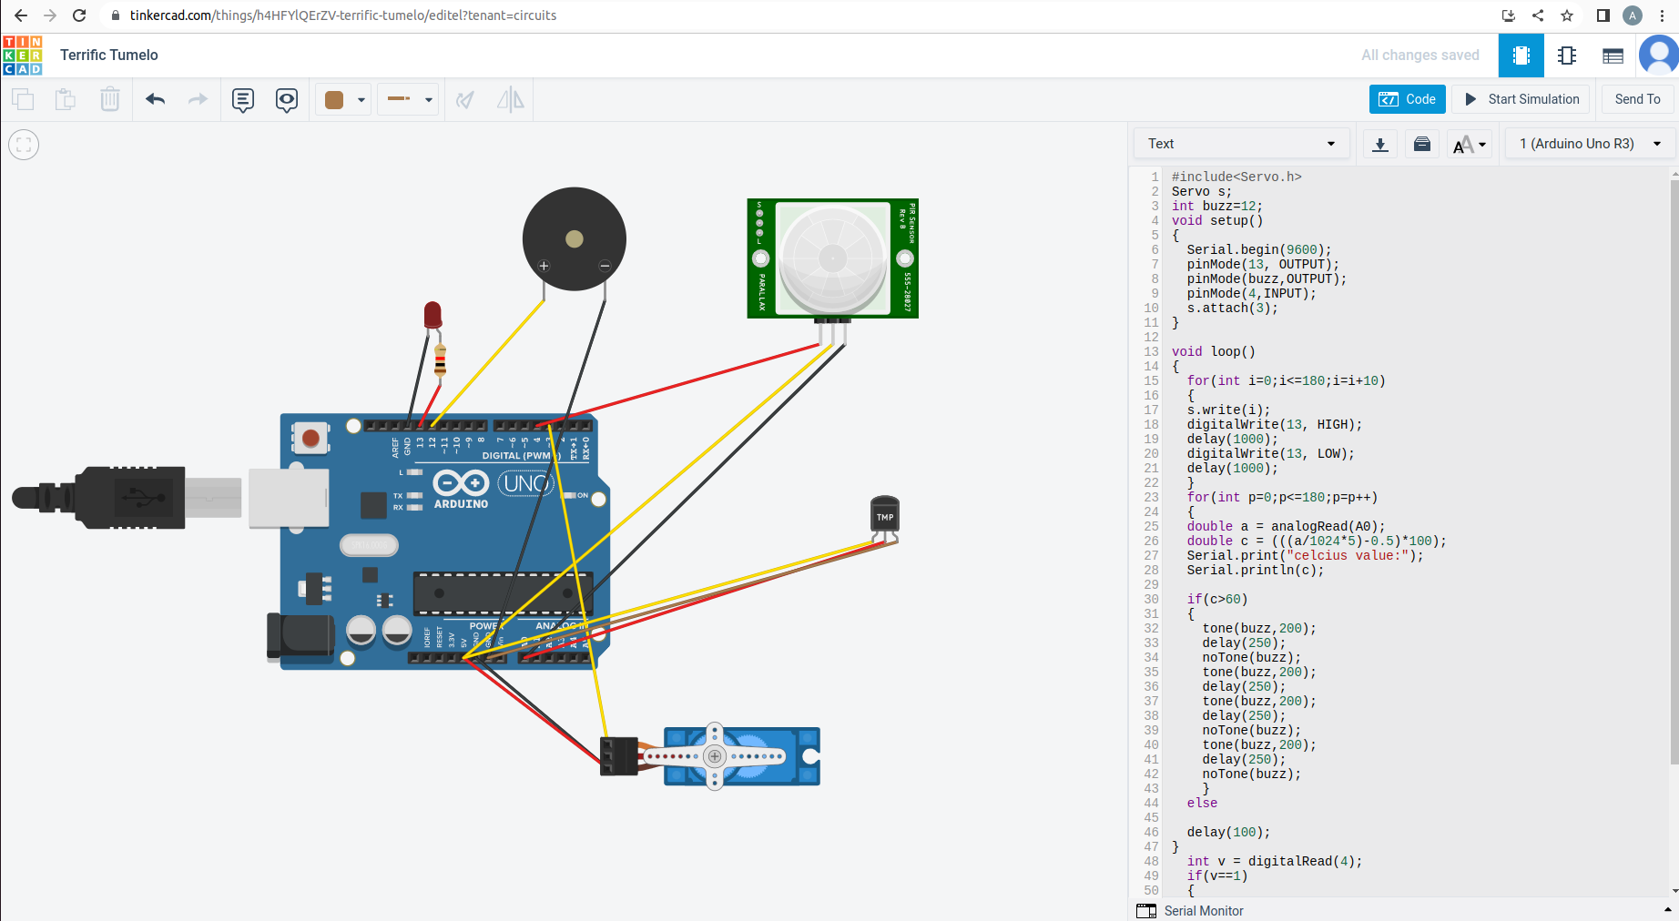
Screenshot :

Code :
#include<Servo.h>
Servo s;
int buzz=12;
void setup()
{
Serial.begin(9600);
pinMode(13, OUTPUT);
pinMode(buzz,OUTPUT);
pinMode(4,INPUT);
s.attach(3);
}

void loop()
{
for(int i=0;i<=180;i=i+10)
{
s.write(i);
digitalWrite(13, HIGH);
delay(1000);
digitalWrite(13, LOW);
delay(1000);
}
for(int p=0;p<=180;p=p++)
{
double a = analogRead(A0);
double c = (((a/1024*5)-0.5)*100);
Serial.print("celcius value:");
Serial.println(c);

if(c>60)
{
tone(buzz,200);
delay(250);
noTone(buzz);
tone(buzz,200);
delay(250);
tone(buzz,200);
delay(250);
noTone(buzz);
tone(buzz,200);
delay(250);
noTone(buzz);
}
else

delay(100);
}
int v = digitalRead(4);
if(v==1)
{
Serial.println("motion detected");
delay(100);
}
else
{
Serial.println("motion not detected");
delay(100);
}

}

